**Financial Request:**

We are investing $70,000 into our business and are requesting a $300,000 loan at 6% annual interest payable over five years. Below are our supporting cash flow and profitability forecasts:

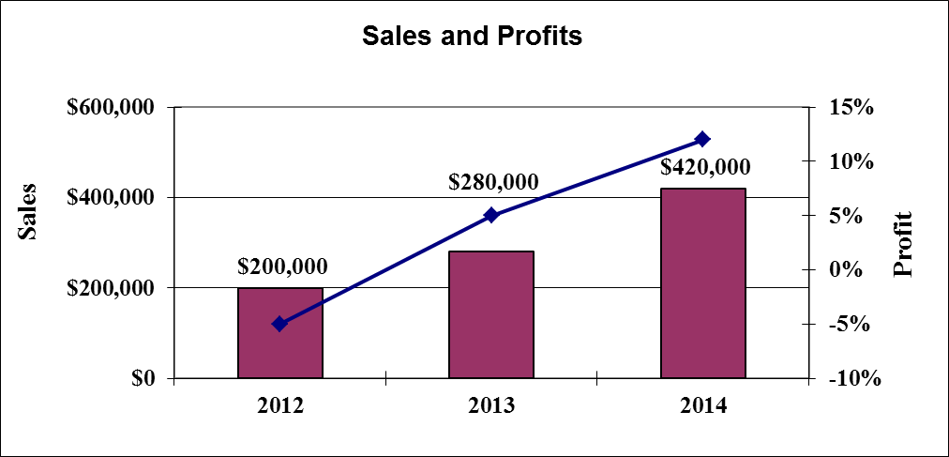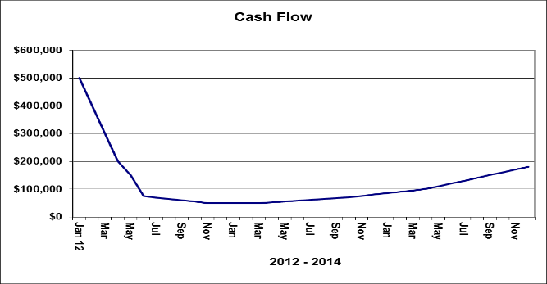

The above forecasts will be monitored against key performance indicators on a continuous basis to allow our company to capitalize on opportunities and respond to changes in market conditions.

|  |  |  |  |  |
| --- | --- | --- | --- | --- |
| **Customer Seg #1** | |  | **Customer Seg #2** | |
| LTV |  |  |  |  |
| CAC |  |  |  |  |
|  |  |  |  |  |
|  |  |  |  |  |
|  |  |  |  |  |
|  |  |  |  |  |

Thank you for your consideration and review of our proposal to borrow $300,000 at 6% over five years. We look forward to the opportunity to meet and discuss this opportunity further.